Session 04 - Lab Assignment: Firewall Wei Cui

Lab Objectives:

1. Follow the instructions for Project 4-3: View Windows Firewall Settings
2. Write a report including screenshots and written descriptions. Be sure to include a screenshot and description for step 10.

Lab Results:

* Open Control Panel
* Click System and Security, then Windows Firewall (Fig.1)
* Click Change notification settings
* Turn off Windows Firewall
* Turn on Windows Firewall
* Advanced Settings
* Click Inbound Rules in the left pane.
* Double click a rule (in this report, iTune is chosen) to open a dialog box associated with that rule. The screen shot is shown below. (Fig.2, 3)

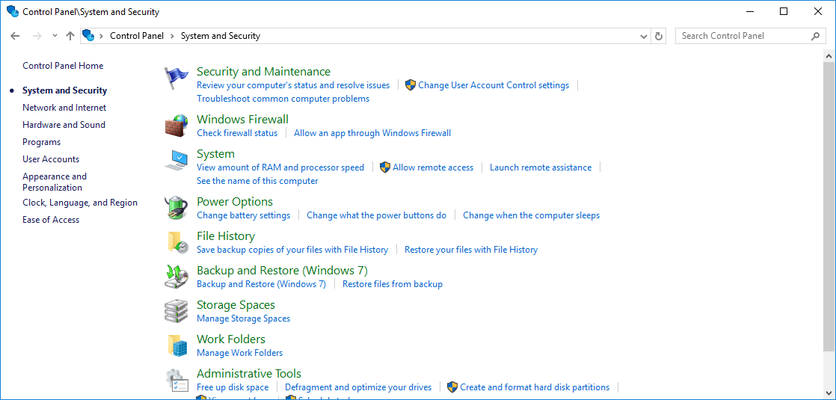Fig.1. Screenshot of System and Security

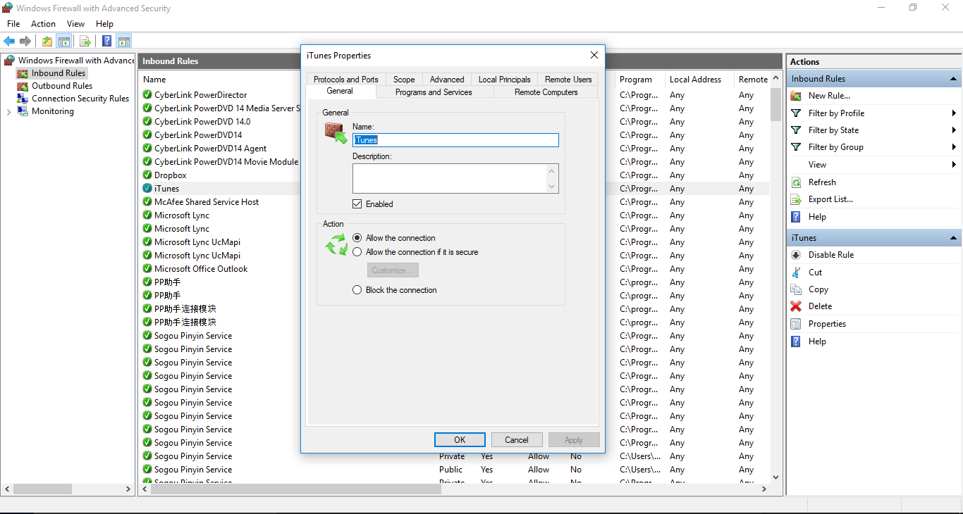

iTunes, one of the inbound rules

Click Inbound Rules

Fig. 2. iTunes Properties – One of Inbound Rules in Windows Firewall with Advanced Settings. The control can be configured on firewall rules

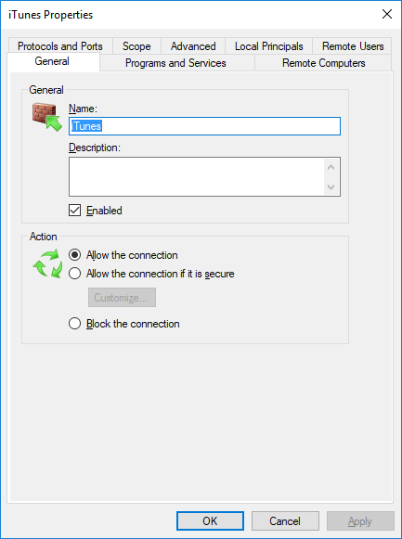

Fig. 3. Tabs can be configured on firewall rules.